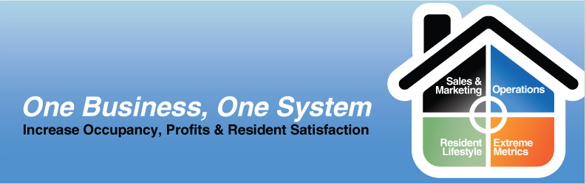

Business Process Questionnaire

Organization & Sales Process

Question | Answer
What is the business stage of your community? (New, established, recently renovated)
What is the current occupancy rate?
What is the resident mix (Independent Living, LTC, Nursing)
What is the average length of stay?
What is the yearly resident turnover?
What is the mix of permanent to temporary residents?
Sales Cycle
What are the main lead sources?
How does a customer contact you to get information?
How are prospects recorded and tracked?
Who talks to potential residents?
How long does it take before a prospect becomes a new resident?
What items do you need to provide to the prospect during the sales process?
What steps are taken to turn an inquiry into a potential resident? What types of activities?
Are the steps in the sales process recorded somewhere as a record for others to see?
How is pricing provided to the potential resident?
Who prepares the quotes?
What is the current ratio of:
Inquiries-Tours?
Tours-Deposits?
Deposits to Move-In’s?
What are your targets for:
Inquiries-tours?
Tours-Deposits?
Deposits to Move-In’s?
Tours
What preparation is done for a tour?
Are multiple department heads involved?
How are staff notified?
How are residents and ‘resident ambassadors’ notified?
When does information get shared so that other departments know that there is a potential resident?
Is there a package prepared for each tour attendee?
Are evaluations, comments and notes recorded from all participants in the tour? Where are they recorded?
What are your tour follow-up procedures?
Data Collected
What type of data is collected about potential residents?
Where is data stored and who is responsible for ensuring that the data is collected?
Does anyone review the data?
Are there specific reasons for various pieces of data that are collected?
Is there specialized information about the potential resident that you need to complete the sale and prepare admission?
Are you currently tracking potential resident interests, medical information, preferences and concerns during each interaction of the sales cycle?
Where is the data recorded?
How is data accumulated during the sales process transferred to operations once the decision is made?
Competitors
Do you have competitors?
How do you track their offerings?
Do you track results by competitors?
Do you have sales literature (either your competitors’ or information you’ve created) that helps address customer concerns during sales?
Do you associate competitors with products of yours to understand how they compete?
Who should maintain competitive information?
Evaluation
What things need to change to make sales more effective?
What things need to stay the same?
What sales reports are used? Desired?
Are there corporate reporting requirements?

Admission Requirements

Question | Answer
Who prepares the pre-admission documents?

How is a new resident profile communicated to the appropriate parties to prepare for admission? How does this information more through to Accounting for invoicing?
What procedures are required from signing of the agreement to one week after move-in?
What is the notification procedure for all departments with a move-in?

What forms, checklists and data capture are required? (Please provide samples)

Marketing Automation

Question | Answer
How do you plan and budget your marketing campaigns?
How do you track marketing costs, activities and schedule for each campaign?
Do you formulate special invitations and events based on the potential resident interests?
Do you have the capability to define/refine/mix lists of prospects/residents/contact for different campaigns?
Do you have a track of campaign responses from prospects? How do you track lead sources?
How do you measure campaign performance? Do you control results against former campaigns? Across multiple communities?
Do you have referral programs in place?
With Residents?
Staff?
Third Parties?
How are the results and rewards monitored?
What are your current most productive marketing tools?
Do you have a nurture campaign-newsletter program or regular e-letters?
Does your community have special focus? How does your marketing reflect this specialty?
What types of reports are used in relation to marketing automation?
What marketing literature do you use?

Analysis

Question | Answer
Is data maintained to identify trend and/or performance for different campaigns?
Do you have a 360-degree for “Resident View” in order to understand resident behavior, frequent contact channels, and preferences?
How do you analyze resident demographics and operational (CRM-related) data in order to generate “Resident Insight”?
Are metrics shared between all of your communities?

Data Migration

Question | Answer
Is there an existing prospective resident database?
Will you be importing this data?
Is the data clean and consistent?
Are there manual lists or Excel Spreadsheets that contain part of the data?

Opportunities

Question | Answer
Do you have sales stages that your sales team follows?
Could you benefit from selecting values (for the potential sale) and probabilities for each opportunity?
Do you schedule activities around these potential deals?
Are there some characteristics that you may want to capture for opportunities?
Can you forecast closure dates for your opportunities so that you can get an accurate picture of what type of business may be occurring in a specific time frame?
Can you forecast revenue and probability of closure?

Sales Literature

Question | Answer
Do you have sales literature (for example, brochures, pictures, or any type of marketing materials) that you send out to customers?
Where do you store this literature? Is it electronic? Does a third-party print it for you?
Can it be incorporated into Retirement Home Software?
Do you want to develop literature that you can send out to prospects in either electronic or paper form?
Should someone be in charge of this, or can anybody add new literature?

Reports

Question | Answer
What types of information are important to capture in reports?
Do you need sample reports, either sales or admissions?
What type of metrics do you intend to capture for internal reporting?
Will you be doing any external reporting?
Does your user have the ability to create their own user-related reports? How do you manage this?-

The Dream

Question | Answer
What is your overall vision of your “prospecting to admission cycle”?

What are the main problems facing your organization today?

Project team knowledge assessment
List the project team members who will participate in the engagement and their relative level of experience with the following products and technologies. Please note the knowledge level as None, Beginner, Intermediate, or Expert.

Name | Role | CRM Experience | Sales | Marketing | Service | IT Infrastructure

